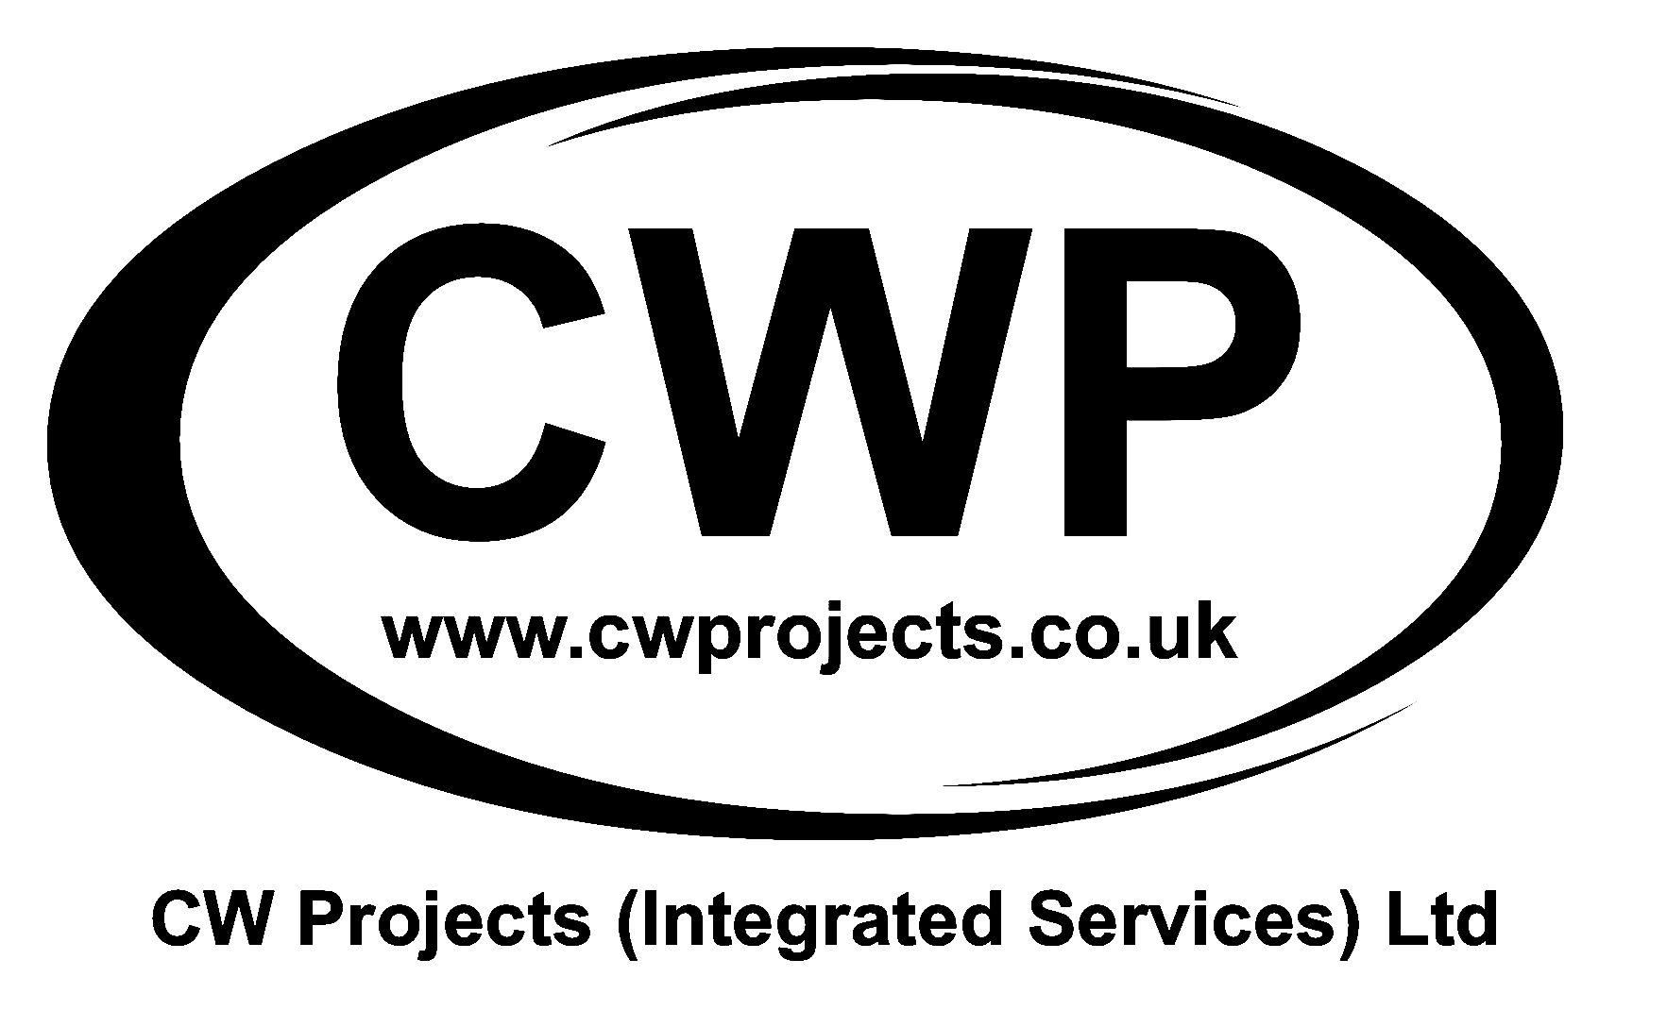  CW Projects Integrated Services Limited  46A Commercial Street  Rothwell  Leeds  LS26 0AW  Tel: 01132821001 | Document Ref  RAMS-2026-SCAR-001

Risk Assessment & Method Statement
External Façade Masonry Repairs
PROJECT  WATERSTONES - Scarborough - Fallen Masonry | LOCATION  Waterstones, Scarborough
VERSION  1.0 | REVIEW DATE  14 Sept 2027
INDUSTRY  Construction | PREPARED BY  Mark Cowling
PLANNED START DATE  14 Sept 2026 | DURATION OF WORKS  1 day

CLIENT
Waterstones
DATE CREATED
14 Sept 2026

Risk Summary Dashboard

11  TOTAL HAZARDS | 11  LOW RISK | 0  MEDIUM RISK | 0  HIGH RISK
Task Description

Remove loose and unsafe masonry from the external façade at approximately 10 metres, make the area safe and replace/repair masonry using ready-mixed mortar. Works will be undertaken from a MEWP while the Waterstones store remains open.
Required PPE

Safety Footwear Gloves Hard Hat Eye / Face Protection High Visibility Clothing Suitable RPE where dust is generated Hearing Protection where required
Tools and Equipment

MEWP • SDS drill • Hammer and bolster • Grinder • General hand tools • Ready-mixed mortar • Replacement masonry • Barriers and warning signage • Tool lanyards / secure tool storage • First aid kit
Safe System of Work Summary

The safe system of work is based on controlled access to the façade by trained CWP operatives using a suitable MEWP, a fully barriered exclusion zone below the workface and maintenance of a safe pedestrian route while the store remains open.
Key Steps
- Report to the store representative and confirm the work area and public access arrangements.
- Fully barrier the area beneath the workface and maintain a safe pedestrian route.
- Inspect the MEWP, ground conditions and façade before work starts.
- Carefully remove loose masonry in controlled sections; retain all debris in the MEWP basket.
- Prepare and replace/repair masonry using ready-mixed mortar.
- Inspect the completed work and only remove barriers once the façade and pavement are safe.
Stop Work Criteria
- Public entering the exclusion zone or loss of safe pedestrian segregation.
- Unexpected widespread façade instability or structural movement.
- Unsafe MEWP ground conditions, defect or emergency-control issue.
- Wind or weather exceeding safe MEWP operating limits.
- Any uncontrolled risk not covered by this RAMS.

Risk Assessment

HAZARD | DESCRIPTION | AFFECTS | INITIAL | CONTROL MEASURES | RESIDUAL | RISK LEVEL
Falling Masonry / Debris | Falling material could strike operatives, customers or members of the public. | Operatives, public, store customers | 5×5=25 | Fully barrier exclusion zone below and around workface. Maintain safe pedestrian route outside danger area. Controlled removal only. All masonry/debris retained in MEWP basket and brought down. Nothing thrown or dropped. Hard hats worn. | 1×3=3 | LOW
Work at Height / MEWP | Fall from platform or unsafe use of MEWP. | Operatives | 5×5=25 | Only appropriately IPAF-trained CWP operatives to operate MEWP. Pre-use inspection. Gates closed. No climbing on guardrails. Use manufacturer-required restraint/fall protection. Keep within platform limits. | 1×3=3 | LOW
MEWP Stability | Overturning due to unsuitable ground or incorrect set-up. | Operatives, public | 5×5=25 | MEWP positioned on level, firm pavement. Ground condition checked before use. Observe rated capacity/outreach and manufacturer instructions. Stabilisers/outriggers used where applicable. | 1×3=3 | LOW
Entrapment / Crushing | Operator trapped between basket and façade/building projection. | Operatives | 5×4=20 | Check façade projections and overhead hazards. Controlled platform movements. Maintain clearance. Ground operative familiar with emergency lowering controls. | 1×3=3 | LOW
Public Interface | Customers/pedestrians enter work area while store remains open. | Public, customers | 5×4=20 | Robust barriers and warning signage. Safe pedestrian route maintained. Supervisor monitors segregation. Stop work immediately if exclusion zone is breached. Do not obstruct fire exits. | 1×2=2 | LOW
Masonry Dust / Silica | Dust from drilling, cutting or grinding. | Operatives, public | 4×4=16 | Minimise cutting/grinding. Use dust suppression/extraction where practicable. Suitable RPE and eye protection. Public kept outside exclusion zone. Avoid dry sweeping of significant dust. | 1×3=3 | LOW
Power Tools | Cuts, vibration, noise, ejected particles or electric shock. | Operatives | 4×4=16 | Competent users only. Pre-use inspection. Correct guards/accessories. Battery/110V equipment as appropriate. Eye and hearing protection as required. Isolate before adjustments. | 1×3=3 | LOW
Manual Handling | Handling masonry, tools and materials in basket. | Operatives | 4×3=12 | Keep loads manageable. Position platform to avoid overreach. Team lift where necessary. Do not exceed MEWP basket capacity. | 1×2=2 | LOW
Falling Tools | Tools or small items falling from platform. | Operatives, public | 5×4=20 | Exclusion zone maintained. Tools secured/stored within basket. Tool lanyards where practicable. No loose items on platform edge. | 1×2=2 | LOW
Weather / Wind | Loss of control or instability during adverse weather. | Operatives, public | 5×4=20 | Check weather before and during works. Comply with MEWP wind limits. Stop in excessive wind, lightning, poor visibility or unsafe conditions. | 1×2=2 | LOW
Unexpected Façade Instability | Removal reveals greater instability than anticipated. | Operatives, public | 5×5=25 | Inspect before disturbance. Remove only controlled sections. Stop work if instability extends beyond planned repair. Maintain/extend exclusion zone and obtain competent technical advice before continuing. | 1×3=3 | LOW

Method Statement

1 | Scope of Works
The works comprise removal of loose/unsafe masonry from the external façade at approximately 10m, making the area safe and replacing/repairing masonry. Access will be by MEWP. The Waterstones store will remain open during the works.
2 | Arrival and Site Coordination
Report to the Waterstones representative. Confirm work location, store access, emergency arrangements and pedestrian route. Paul Highfield will supervise the works and brief both operatives.
3 | Exclusion Zone and Public Protection
Establish a robust, fully barriered exclusion zone beneath and around the active workface before raising the MEWP. Provide warning signage. A clearly defined safe pedestrian route must remain available past the works. The public must never pass beneath the active workface.
4 | MEWP Set-Up
Position the MEWP on the identified level, firm pavement. Check ground condition, overhead obstructions, façade projections, street furniture and other hazards. Complete pre-use checks and confirm emergency lowering controls. Only appropriately IPAF-trained CWP operatives may operate the MEWP.
5 | Access to Workface
Raise the platform in a controlled manner. Keep the basket gate closed and remain within the guardrails. Do not climb or stand on rails. Use manufacturer-required restraint/fall protection for the MEWP type.
6 | Initial Façade Inspection
Inspect the affected masonry from a safe position before disturbing it. Identify loose sections and the likely sequence of removal. Do not place the platform directly beneath visibly unstable material where avoidable.
7 | Removal of Loose Masonry
Carefully remove loose or defective masonry in controlled sections using hand tools, SDS drill or grinder only as necessary. Avoid uncontrolled breakout. All removed masonry and debris must remain inside the MEWP basket and be brought down with the platform.
8 | Dust and Tool Controls
Minimise grinding/cutting. Use suitable extraction or suppression where practicable. Wear eye protection and suitable RPE where masonry dust is generated. Keep tools maintained and guards fitted. Secure tools within the basket and use lanyards where practicable.
9 | Repair / Replacement
Prepare sound surrounding masonry and install suitable replacement masonry using ready-mixed mortar. Work progressively and maintain stability of the remaining façade at all times.
10 | Unexpected Instability
If removal exposes widespread instability, cracking, movement or an unsafe substrate, stop work. Lower the platform, maintain or extend the exclusion zone and refer the condition to the client/project manager for competent technical assessment before continuing.
11 | Completion
Inspect the repaired area and adjacent masonry for obvious remaining loose material. Lower the MEWP with all tools and debris retained. Remove waste and clean the pavement.
12 | Handover
Barriers may only be removed when Paul Highfield is satisfied there is no remaining risk of falling material and the pedestrian route is clean and safe. Sign out with the store representative.

Additional Controls

13 | PPE
Minimum PPE: safety footwear, high-visibility clothing, gloves, hard hat and eye protection. Suitable RPE is required where masonry dust is generated. Hearing protection is to be used for noisy powered operations.
14 | Manual Handling
Masonry pieces, tools and materials are to be kept to manageable weights. Avoid overreaching from the MEWP. Team lifting is to be used where necessary and the MEWP platform safe working load must not be exceeded.
15 | Dust / Silica
Dust generation is to be reduced at source. Grinding and drilling are to be limited to what is necessary. Suitable extraction/suppression should be used where practicable. Significant dust is not to be dry swept.
16 | Noise
Keep powered-tool use to the minimum necessary. Hearing protection is to be worn where noise levels warrant it, and noisy work should be coordinated to reduce disturbance to the operating store.
17 | Housekeeping and Waste
Masonry debris and packaging are to be retained and removed safely. Nothing is to be dropped from height. Keep the pavement, pedestrian route and MEWP access area free of trip hazards.
18 | Weather
MEWP use must remain within the manufacturer's weather and wind limitations. Work is to cease during excessive wind, lightning, poor visibility or other conditions that could affect safe operation.
19 | Store / Fire Routes
The store remains open. Barriers and equipment must not obstruct store entrances, designated fire exits or emergency routes. If the fire alarm sounds, make the work safe, lower the platform if safe to do so and follow the store evacuation procedure.
20 | Supervision
Paul Highfield will supervise the works and ensure the RAMS remains suitable for actual site conditions. Any material change in scope, access method or façade condition requires review before work continues.

Emergency Contacts

Site Emergency Contact  Paul Highfield | First Aider  Olly Ogden
Works Manager  Paul Highfield | Nearest Hospital  Scarborough Hospital Emergency Department  Woodlands Drive, Scarborough, YO12 6QL
Emergency Procedures

Fire
Stop work and follow the Waterstones store fire procedure. If safe, lower the MEWP and leave it secure. Evacuate by the instructed route and proceed to the store's designated assembly point. Call 999 where required.

Accident
Stop work immediately and make the area safe. First aid is to be administered by Olly Ogden. For serious injury call 999. The nearest A&E is Scarborough Hospital Emergency Department, Woodlands Drive, Scarborough, YO12 6QL. Record and report the incident in accordance with CWP procedures.

MEWP Emergency / Entrapment
Use the MEWP emergency lowering procedure. The ground operative must be familiar with the emergency controls before work starts. Call emergency services if there is injury, entrapment or the platform cannot be safely recovered.

Falling / Unstable Masonry
Stop work, keep everyone clear and extend the exclusion zone as necessary. Do not recommence until the façade condition has been assessed and a safe method agreed.

Services Damage
If any electrical or other service is damaged, stop work, keep people clear and isolate the service if safe and competent to do so. Inform the store/client immediately and do not attempt unauthorised repairs.

Document Approval and Sign-Off

Prepared by
Mark Cowling
Additional Signatures
Name (Print) | Signature | Date

By signing this document, I confirm that I have read and understood the Risk Assessment and Method Statement. I agree to follow all safety procedures and control measures outlined in this document. I understand my responsibilities and will report any hazards or concerns to my supervisor immediately.

